THE ADVANTAGES OF SMART GLASS FILM PROJECTION AND LED SCREEN AD

www.HelloGlass.com

The cost of use LED is higher than SMART GLASS FILM projection.
SMART GLASS FILM projection is better at energy saving (consume less electricity).
The view angle range of SMART GLASS FILM projection is wider than LED screen.
SMART GLASS FILM projection is more flexible to install, you can use the building windows as a projection screen,. And the SMART GLASS FILM is lighter to install.
SMART GLASS FILM projection has more option. You can use it as a normal windows, or privacy partition.
The viewing effect under sunlight of smart glass film projection is better than LED screen.

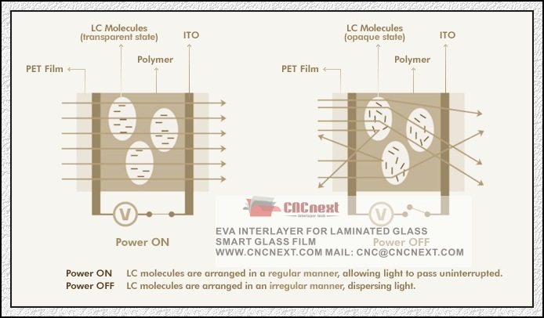
-If The Purity of Liquid Crystal is bad, the transparency of Privacy Glass Film(PDLC Film, SPD Film, Magic Glass Film) will be lower.

-If The Purity of Liquid Crystal is bad, the life of Privacy Glass Film(PDLC Film, SPD Film, Magic Glass Film) will be shorter. Because the impurities will accelerate the decompose of the Privacy Glass Film(PDLC Film, SPD Film, Magic Glass Film) materials under the high temperature, UV radiation.

-If The Purity of Liquid Crystal is bad, the application temperature range of Privacy Glass Film(PDLC Film, SPD Film, Magic Glass Film) will be narrow.
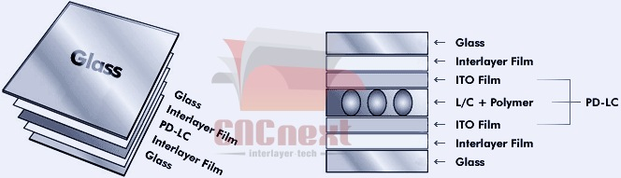
+So, our Privacy Glass Film(PDLC Film, SPD Film, Magic Glass Film) only adopt the highest purity liquid crystal for producing our Privacy Glass Film(PDLC Film, SPD Film, Magic Glass Film) products.

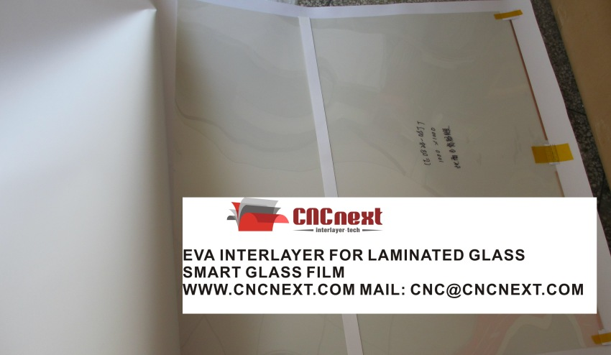
All rights reserved by CNC-INTERLAYER TECH:
【Product 1】CNC-Force® EVA INERLAYER FOR ARCHITECTURAL LAMINATED GLASS
【Product 2】CNC-Smart® SMART FILM FOR PRIVACY SWITCHABLE GLASS
【Product 3】CNC-Shield® PVB INTERLAYER FOR AUTOMOTIVE WINDSHIELD GLASS
Web: www.CNCnext.com www.HelloGlass.com
Mail: cnc@cncnext.com
benext77@gmail.com/
benext77@hotmail.com

